RAILWAY TICKET FARE CALCULATION Python Case Study

1.Problem Statement
Develop a Python program to calculate railway fares for multiple passengers. The program accepts distance and travel class, applies slab-wise distance charges and age-based concessions, adds reservation charges, prints individual and total fares, and optionally calculates a 20% cancellation penalty and the refundable amount. An extended version must demonstrate lists and tuples to store passenger details.
2. Objectives
• Accept and validate the number of passengers, journey distance and travel class.
• Apply distance slabs and Sleeper/AC fare rules accurately.
• Use conditions and loops to compute fares for each passenger.
• Use strings for passenger names and cancellation responses.
• Store passenger records in tuples inside a list.
• Display fares, total cost and optional cancellation refund.

3. Assumptions and Fare Rules
• The fare model is educational, not an official Indian Railways tariff.
• First 100 km: Rs. 1/km; next 400 km: Rs. 0.80/km; distance beyond 500 km: Rs. 0.60/km.
• AC doubles the computed base fare. Reservation charge per paid ticket: Sleeper Rs. 30; AC Rs. 60.
• Age below 5: free, including reservation. Ages 5–11: 50% of base plus reservation. Ages 12–59: full base plus reservation. Ages 60 and above: 60% of base plus reservation.
• Negative age is rejected and that passenger is skipped, as in the original program. Passenger count is not re-requested.
• Cancellation applies to the total of valid tickets

4. STEP BY STEP ALGORITHM
1. START.
2. Read passenger count n and journey distance.
3. Show travel classes and read travel_class (1 or 2). Set total to zero.
4. If n <= 0, distance <= 0, or class is invalid, print Invalid input and STOP.
5. Compute base fare using the 0–100, 100–500, or above-500 km slab. Railway Fare Case Study | Page 1
6. If AC, double base and set reservation = 60; otherwise reservation = 30.
7. Repeat n times: read passenger name and age.
8. If age is negative, print Invalid age and continue to the next iteration.
9. Select age category; compute passenger fare with concession and reservation.
10. Add fare to total and print the passenger's fare.
11. After the loop, print total railway fare.
12. Read cancellation choice; if it is yes (case-insensitive), calculate penalty = total × 0.20 and refund = total − penalty; print both.
13. STOP

5. FLOW CHART

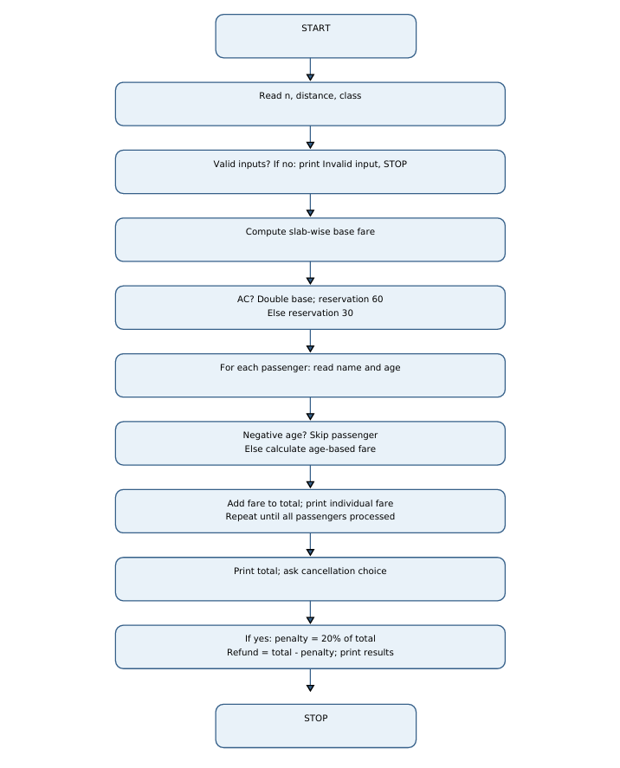

Flowchart note: The passenger-processing step loops back to read the next passenger until n entries have been processed. Invalid ages skip fare addition

6. Pseudocode BEGIN
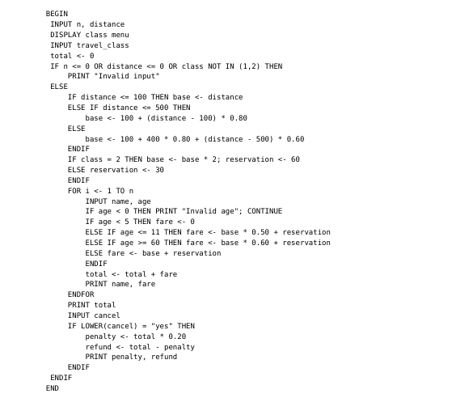

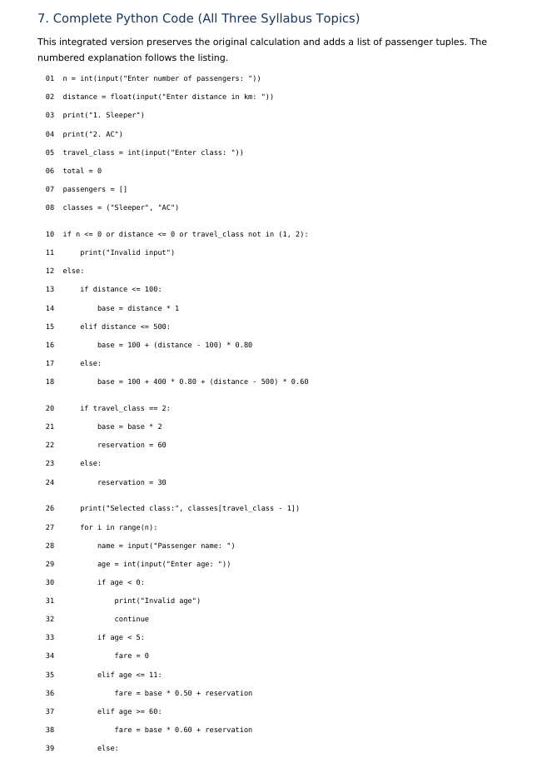
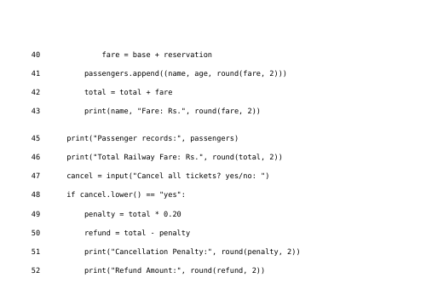

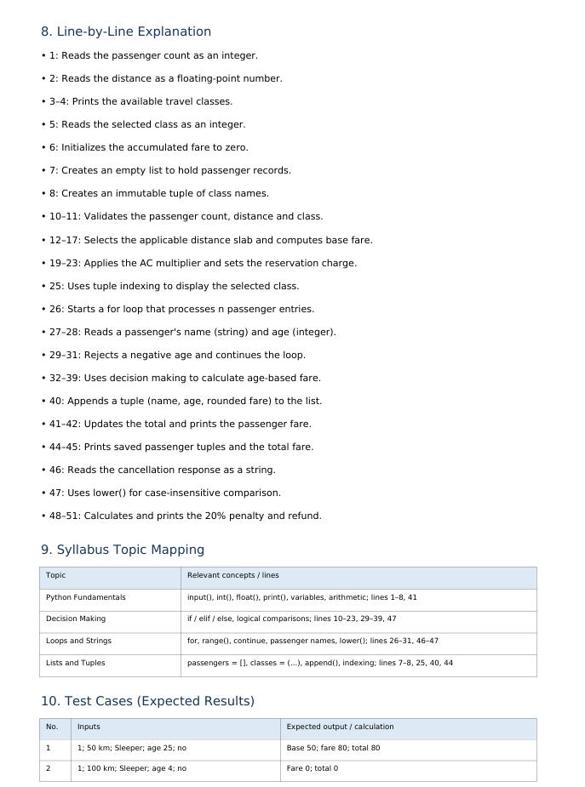

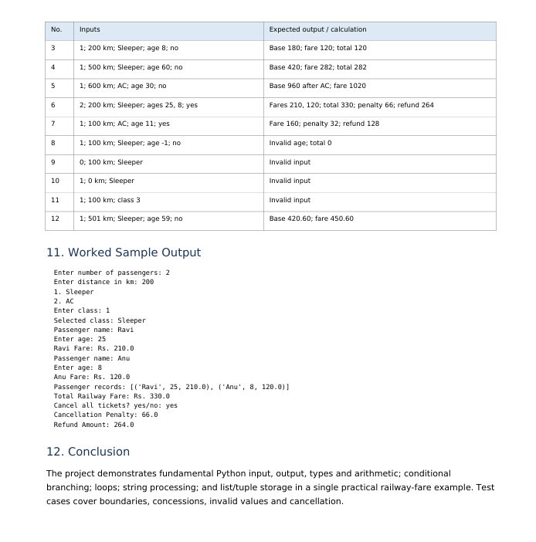

Output of my website

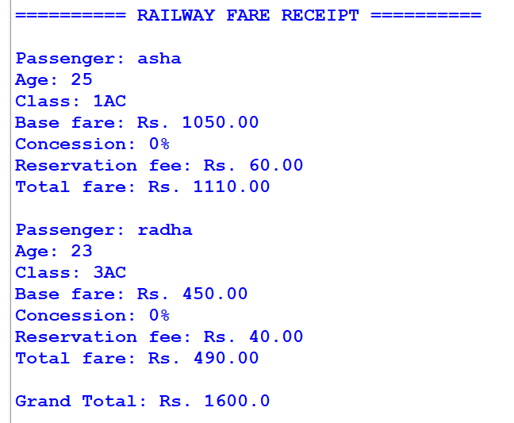

CONCLUSION OF MY WEBSITE
The project demonstrates fundamental Python input, output, types and arithmetic; conditional branching; loops; string processing; and list/tuple storage in a single practical railway-fare example. Test cases cover boundaries, concessions, invalid values and cancellation

